Classic Projects: LNER Class A3 4472 Flying Scotsman
18 May 2015
By Nick Smith
More Sharing ServicesShare|Share on facebookShare on twitterShare on emailShare on print
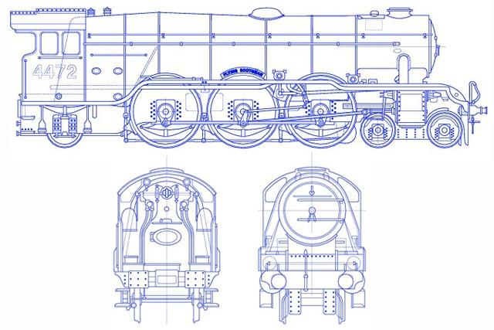
Find out why the Flying Scotsman is a classic
Date: 24 February 1923
Designer: Sir Nigel Gresley
Cost: 1963 scrap value £3,000
If all goes to plan the world's most famous railway engine will literally be back on track this summer. The Flying Scotsman steam locomotive LNER Class A3 4472 will, according to current owner the National Railway Museum, emerge from a heavy overhaul in as railworthy a condition as when it left the Doncaster works where it was built on 24 February 1923.
The Flying Scotsman locomotive (not to be confused with later trains of the same name, nor indeed the London-Edinburgh service from which it took its name) has a proud engineering heritage that has resulted in two world records. While in service, in 1934 it became the first steam locomotive to clock up a recorded speed of 100mph (approximately 160km/h). In retirement, while on tour of Australia in the late 1980s, it notched up the longest ever non-stop distance by a steam locomotive: 422 miles (679km).
The engine made its first dramatic impact on the public at the British Empire Exhibition in 1924, by which time the London and North Eastern Railway company (LNER) had changed its number from the orginal 1472 to 4472. Destined to become a media superstar, the Scotsman featured heavily in LNER's promotional activities. By 1929 it had also appeared in the black and white thriller 'The Flying Scotsman', showing Hollywood heartthrob Ray Milland performing death-defying stunts on the fast-moving train. This so disturbed the Scotsman's designer and chief engineer at LNER, Sir Nigel Gresley, that a disclaimer was later added to the film distancing the operator from the 'dramatic licence' used in portraying the locomotive's safety equipment and procedures.
The more prosaic purpose of the locomotive was to make travel between London and Edinburgh easy. Within a few years of going into service the addition of a modified 'corridor tender' meant the journey had become non-stop with an overall time of just eight hours. The corridor allowed crews to change by walking through the tender from the passenger coaches while the train was in motion.
After the Second World War, Scotsman was rebuilt from its orginal Gresley A1 Pacific design to the more efficient A3 specification, with a new boiler.
But in 1948, Britain's rail network was nationalised. This led to the replacement of out-moded steam engines by diesel trains and moves towards electrification of the network. In 1963, a mere 40 years after its arrival, the Flying Scotsman was withdrawn from service, tired and unrecognisable in its British Railways livery and bearing the number 60103.
Had it not been for railway preservationist Alan Pegler, the story might have ended there. With the political support of Prime Minister Harold Wilson, Pegler bought the locomotive and took it back to Doncaster, where he set about restoring it to its 1930s condition. It was taken to the USA to promote British exports, but complying with US regulation was costly, and with a change of government in 1970, political will evaporated, public funding was withdrawn and Pegler was declared bankrupt.
Several long decades of mixed fortune followed. British businessman William McAlpine owned the engine at one point in the 1980s, as did record producer Pete Waterman in the 1990s, followed by businessman Tony Marchington. But none could pour in the sums of money it needed to survive. However, in 2004 the engine's future was finally secured, when it was returned to public ownership thanks to money raised by the British people, Sir Richard Branson and the National Heritage Memorial Fund.
It could travel 392 miles (631 km) from London to Edinburgh in eight hours non-stop.
It was the first coal-powered locomotive to run non-stop between London and Edinburgh.
The locomotive was once part-owned by record producer Pete Waterman.
It was the first steam locomotive to reach a confirmed 100mph.
Sir Richard Branson is one of the donors to the current restoration.
It recorded the longest ever non-stop run by a steam loco of 422 miles in Australia during its 1988-9 tour.
It has been repainted in several colours, notably green, black and blue.
Its original number was 1472.
It is now owned by the National Railway Museum in York

